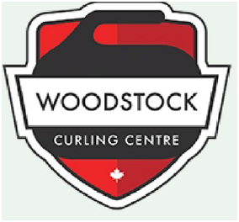



Watching all that Olympic curling on TV?

No Experience? No equipment? No Problem!

No matter your age or fitness level, you too can start curling!

Throw your first rock by signing up for the

**Woodstock Curling Centre’s**

**Six week Learn to Curl League**

**February 28 – April 4, 2018**

**Wednesdays 6:30 – 8:30 pm**

**$85 +HST**

Includes off-ice and on-ice instruction followed by curling games

To register or for more details:

Email [curl@woodstockcc.on.ca](mailto:curl@woodstockcc.on.ca)

Type “Learn to Curl League” in your subject line

Or call 519-539-9512

www.woodstockcurling.com